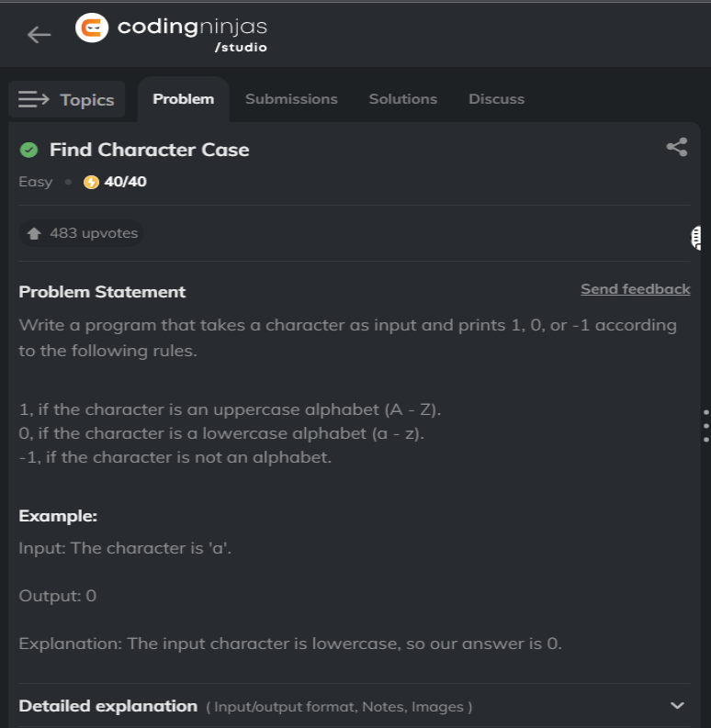

**Java code**

import java.util.Scanner;

public class Solution {

public static void main(String[] args) {

Scanner sc=new Scanner(System.in);

char a=sc.next().charAt(0);

if(Character.isUpperCase(a))

System.out.println("1");

else if(Character.isLowerCase(a))

System.out.println("0");

else System.out.println("-1");

}

}